Woodcrest Retreat Summer Camp
Camper Comments:
- Camp, taught and got me learning about the Bible, was amazing and changed me in ways I never thought would happen.
- I love camp! It is awesome and I loved talking with all the campers and my counselor. I don’t want to leave.
- I really liked spending time with God! This is the best camp I ever went to.
- I liked the singing, the awesome food, and learned that there is more to God than love.
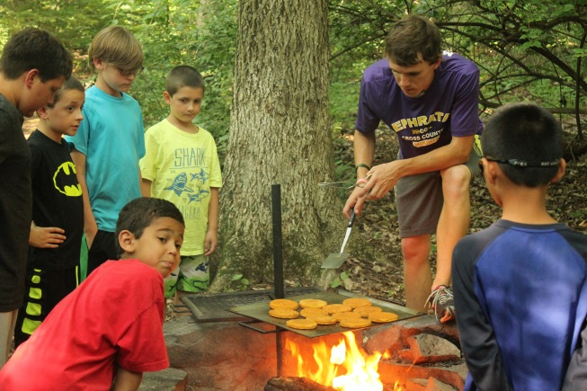
- I feel so much closer to God than I did at the beginning of the week. So happy I choose this camp for my first overnight camp! Thank you for making this a fun, safe, and spirit enriching week. I have so many new friends and I hope to come back next year.
- It was great to get away from home life and get closer to God. It was awesome to get active with a big group of people. I LOVED EVERYTHING!
- I learned a lot about Jesus and I now know that when I am confused, sad, etc. He will always be there for me.
- I liked Woodcrest way better than the other camp I went to.
- Something I learned at camp this week is that just because you have a Bible and go to church does not mean you are a Christian.
- I feel like my faith has been turned from a small twig into a mighty redwood.
- The speakers have been amazingly powerful part of my journey in faith and the songs paired with the seemingly remoteness of the area make it breathtaking.
- I got closer with God this year. The fireside message opened my eyes and I always enjoy having a set time to be alone with God, it should be longer.
- Fireside really hit me this week. After 5 years this is my best year here.
- This week woke me up to Christ and motivated me to pursue God and take Christianity seriously.
- *I love Woodcrest t was my first time and I was very nervous but it was an amazing ride.
Parent Comments:
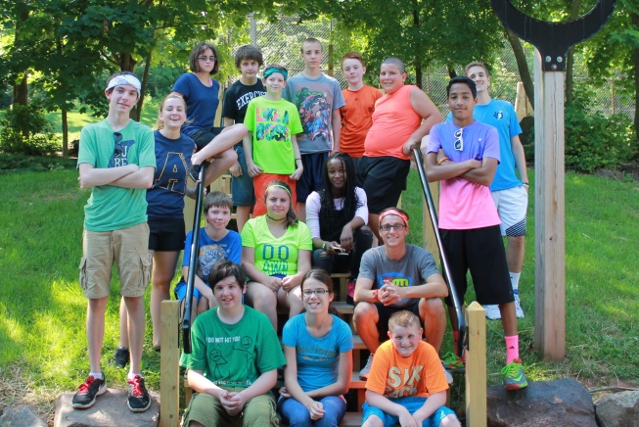
- My children enjoy Woodcrest and specifically enjoy the pool, waterslide, Indian Rocks and adventure playground. They prefer this camp to others they have gone to!
- My children are so tired by the end of the day. I think that having Bible as part of the experience all week helped the girls make connections to what they hear/learn at church. They LOVED this camp! Thank you.
- Each day my son and his cousin explaining the whole day one activity at a time! This was his first time away from home “on his own” your camp helped ease that transition. He liked his counselor and enjoyed that they prayed while they walked to lunch. Thanks for all your hard work. Camp was awesome!
(Over)
- Woodcrest has always done a great job of impacting young lives for Christ. My family has been blessed so much over the years by your ministry.
- Thank you for providing a fun safe week for the campers. Thank you for teaching them about God and true salvation.
- We just think Woodcrest is fantastic. The teaching is biblically solid and it's FUN for the kids. There are kids who come from all different backgrounds and who are introduced or reminded of the love of Jesus here...and that love shows through the staff.
- My son is sad that he only has a few more years left as a camper. He loves going to Woodcrest every Summer. He is talking about maybe becoming a counselor.
- We are beyond thankful for you and the experience God gives our kids through your organization.
- Thank you, my son had such a positive experience and I like the fact that he learned more about God.
Counselor Glory Stories:
- While walking down the trail to lunch several of my campers started singing “I have decided to follow Jesus” and a few other songs about God, together.
- She had a lot of questions about God and Jesus. So we talked about what it means to accept Christ, then I asked her if she ever accepted Christ and she said “No”. I asked her if she wants to and she said “yeah I think I probably should “So we prayed together and she did. We talked ten minutes afterward just answering questions.
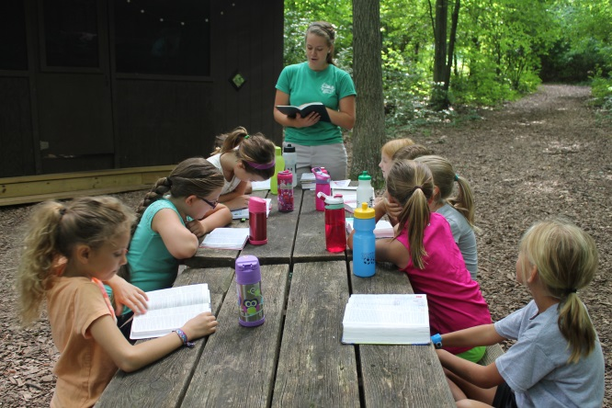
- Next on our schedule was the “Prayer Walk” After what seemed like a hectic few minutes of stopping at the restroom, then regrouping and quieting an argument I had everyone sit down in a circle. I wasn’t sure how prayer time was going to go due to the recent chaos. I was pleasantly surprised. We started talking about prayer and took prayer requests. The kids participated by answering my questions, asking for prayer and 2 children even volunteered to pray! Afterward, the TSS worker who was assisting one of my campers told me that she really likes how Woodcrest has the spiritual aspect and how we take time to talk to the kids and teach them. She said a lot of other camps just move kids from one area of unstructured play to the next. So prayer time was the highlight of my day.
- A camper broke his ankle during game time and was waiting at the hospital to see if he needed surgery. When the doctor told him he did not need surgery he looked at his mom and said “Do you know why I don’t need surgery? “Because everyone at Woodcrest is praying for me”. Mom said “That is the power of prayer honey.” He was in high spirits, minimal pain and has already asked if he could attend a full week of camp next summer. Praise God.
- One of my campers said “I love Bible here at camp so much. Sometimes at church when our pastor is talking I don’t really understand what he is saying. But here at camp they make the Bible lessons easy to understand. You guys use kid language and I like that.”
- One of my campers had some difficult behaviors to handle throughout the week. He was particularly disruptive during Bible. However by Friday he sat really well through Bible and he was helping his teammates learn the Bible memory verse at lunch.
- Two of my campers told me that they felt like God wasn’t first in their lives. They asked me for ways that they could get closer to God. I suggested setting aside five minutes to pray each day and find a bible reading plan. I also shared some of my own testimony with them.

Attendance
- 907 Day Campers
- 512 Overnight Campers
- 1,419 Total campers up 5.3% from 2017
- 14% Unchurched

Results
- 16 accepted Christ (that we know of)
- 5 rededications
- All drawn one step closer to Jesus
- Staff’s faith deepened
2016

